Practical - 14
Practical Title : Admin Dashboard with Role-Based Access Control, Dynamic Menu, and Audit Log

Develop an admin dashboard that displays user statistics, student count, event count and latest registrations. Restrict access to admin users only and show dynamic menu options based on role.

Theory
1. Are dashboard values loaded dynamically from the database?
- Yes, dashboard values are loaded dynamically from the database.
- The system fetches the latest records and displays updated counts and statistics.
- Dashboard values refresh based on the available database data.
2. Is access restricted to admin users?
- Yes, access to admin features is restricted to authorized admin users.
- Regular users cannot access or modify admin functionalities.
- Authentication and role-based access control ensure system security.
3. Are role-based menus working?
- Yes, role-based menus display options according to the user's assigned role.
- Admins can access administrative features, while regular users see only permitted options.
- Unauthorized menu items remain hidden to ensure proper access control.
4. Are important admin actions recorded in audit_logs?
- Yes, important admin actions are recorded in the audit_logs table.
- It stores details such as the admin action, timestamp, and user information for tracking.
- These logs help maintain security, accountability, and traceability.
Implementation/Output/Result

My learning codes: https://drive.google.com/file/d/1CPP3uUq3gdKZxC3pFB7iheZVU7FCImSx/view?usp=drive_link

Evidence of Work (Screenshots)
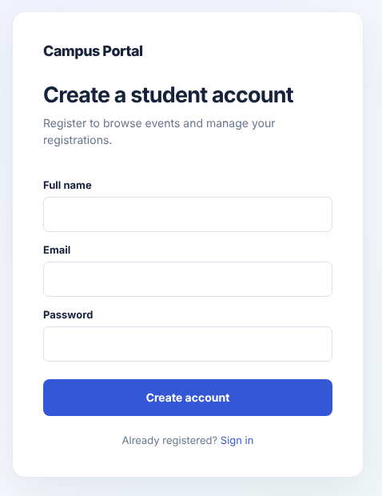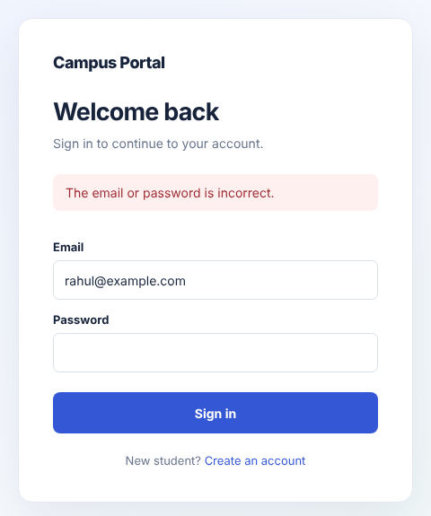

GitHub Repository Link:
Khushi-Thakor2007/Student-Hub-Portal
C. Challenges Faced:
- Implementing server-side access control on every admin page.
- Displaying live dashboard counts and the latest registrations using database queries.
- Recording admin actions in audit_logs with user details and timestamps.
- Managing role-based menus and preventing unauthorized access.
D. Learning Outcomes:
- Learned to create a dashboard with real-time database statistics.
- Understood how to implement role-based access control.
- Learned to display menus according to user roles.
- Understood the importance of audit logging for security, accountability, and traceability.

Faculty Remarks:

